Read the picture and then answer the question in Thai. (No.1 )

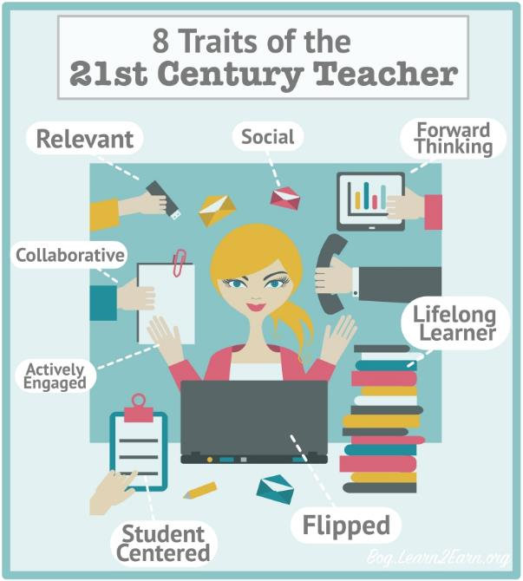

- จากข้อมูลที่ปรากฏในภาพ ท่านได้รับรู้เกี่ยวกับอะไร
……………………………………………………………………………………………………………………………
………………………………………………………………………………………………………………………………
………………………………………………………………………………………………………………………………
………………………………………………………………………………………………………………………………
………………………………………………………………………………………………………………………………
……………………………………………………………………………………………………………………………
………………………………………………………………………………………………………………………………
………………………………………………………………………………………………………………………………
………………………………………………………………………………………………………………………………
………………………………………………………………………………………………………………………………
………………………………………………………………………………………………………………………………
……………………………………………………………………………………………………………………………
………………………………………………………………………………………………………………………………

- ให้ท่านเลือก 3ประเด็น ที่ท่านคิดว่ามีความจำเป็นเร่งด่วนที่ต้องนำไปพัฒนาครูของท่าน
………………………………………………………………………………………………………………………
………………………………………………………………………………………………………………………..
………………………………………………………………………………………………………………………….
…………………………………………………………………………………………………………………………..
……………………………………………………………………………………………………………………………
…………………………………………………………………………………………………………………………..

- ท่านให้ความสำคัญกับประเด็นใดมากที่สุด เพราะเหตุใด
………………………………………………………………………………………………………………………………………………………………………………………………………………………………………………………………………………………………………………………………………………………………………………………………………………………………………………………………………………………………………………………………………………………………………………………………………………………………………………………………………………………………………………………………………………………………………………………………………………………………………………………………………………………………………………………………………………………………………………………………………………………………………………………………………………………………………………………………………………………………………………………………………………………………………………………………………………………………………………………………………………………………………………………………………………………………………………………………………………………………………………………………………………………………………………………………………………………………………………………………………………………………………………………………………………………………………………………………………………………………………………………………

