Read the passage and then answer the qoestion in Thai (No.2)

1st Century Skills
The 21st Century Skills are the skills that students need to develop in order to live, learn, and thrive in a 21st century environment and to succeed in college and careers. Content knowledge and the 21st Century Skills combine to create the 21st century learner outcomes. The learner outcomes provide what is to be learned and demonstrated. DoDEA’s 21st Century Skills were adapted from Tony Wagner’s Seven Survival Skills.
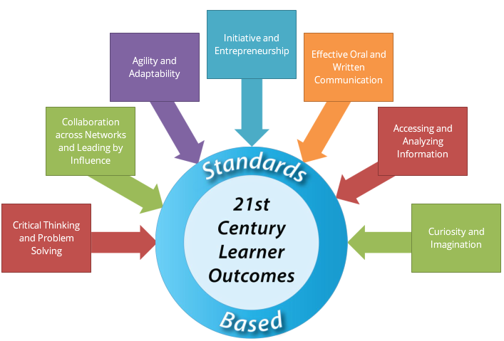

ความเป็นผู้นำด้านภาษาต่างประเทศและเทคโนโลยี
ชื่อ – สกุล .............................................................................โรงเรียน ...........................................
........................................................................................................................................................
- จากภาพ ท่านได้รับรู้ข้อมูลเกี่ยวกับอะไร ประกอบด้วยประเด็นใดบ้าง
………………………………………………………………………………………………………………………………………………………………………………………………………………………………………………………………………………………………………………………………………………………………………………………………………………………………………………………………………………………………………………………………………………………………………………………………………………………………………………………………………………………………………………………………………………………………………………………………………………………………………………………………………………………………………………………………………………………………………………………………………………………………………………………………………………………………………………………………………………………………………………………………………………………………………………………………………………………………………………………………………………………………………………………………………………………………………………………………………………………………………………………………………………………………………………………………
- ให้ท่านระบุ 3 ประเด็นที่ท่านต้องเร่งพัฒนานักเรียนของท่าน
………………………………………………………………………………………………………………………………………………………………………………………………………………………………………………………………………………………………………………………………………………………………………………………………………………………………………………………………………………………………………………………………………………………………………………………………………………………………………………………………………………………………………………………………………………………………………………………………………………………………………………………………………………………………………………………………………………………………………………………………………………………………………………………………………………………………………………………………………………………………………………………………

.
- ท่านคิดว่าประเด็นใดพัฒนายากที่สุด เพราะเหตุใด
……………………………………………………………………………………………………………………………………………………………………………………………………………………………………………………………………………………………………………………………………………………………………………………………………………………………………………………………………………………………………………………………………………………………………………………………………………………………………………………………………………………………………………………………………………………………………………………………………………………………………………………………………………………………………………………………………………………………………………………………………………………………………………………………………………………………………………………………………………………………………………………………………………………………………………………………………………………………………………………………………………………………………………………………………………………………………………………………………………………………………………………………………………………………………………………………………………………………………………………………………………………………………………………………………………………………………………………………………………………………………………………………………………………………………………………………………………..

